DAB 304 Project Proposal: Predicting Hospital Readmissions in Diabetic Patients Using Machine Learning
Group 8
Group Members: Aum Gajjar, Priyanka Sharma, Souravdeep Singh, Sakshi
Course: Healthcare Analytics
Date: January 31, 2026
Problem Statement
Hospital readmissions within 30 days of discharge represent a critical healthcare challenge, costing the U.S. healthcare system over $52.4 billion annually[1]. Diabetic patients face particularly high readmission risks due to complex medication regimens, multiple comorbidities, and disease management challenges. Currently, healthcare providers lack accurate predictive tools to identify high-risk diabetic patients who would benefit from targeted post-discharge interventions.
The core problem: Can we develop a reliable machine learning model to predict 30-day hospital readmissions in diabetic patients using electronic health record data, enabling proactive intervention strategies and reducing preventable readmissions?
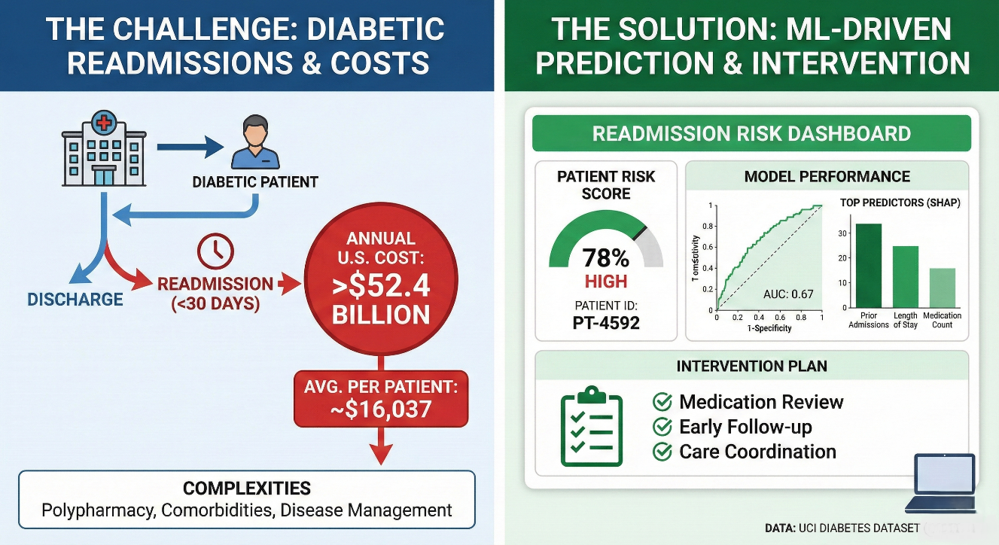
Introduction
This project aims to develop and evaluate machine learning models to predict 30-day hospital readmissions in diabetic patients. We will utilize the Diabetes 130-US Hospitals for Years 1999-2008 dataset from the UCI Machine Learning Repository[2], containing 101,766 de-identified inpatient encounters from 130 U.S. hospitals with over 50 clinical features, including demographics, diagnoses, medications, and readmission status.
Recent studies demonstrate that machine learning models outperform traditional clinical scoring systems by 25-55% in identifying high-risk patients[3]. Research using this UCI dataset has achieved AUC-ROC scores of 0.63-0.67, with XGBoost showing superior performance[4]. Key predictive features include prior admissions, hospital length of stay, medication counts, and diabetes medication patterns[4][5].
This project aligns with DAB 304 objectives by encompassing data preprocessing, exploratory analysis, predictive modelling (Logistic Regression, Random Forest, XGBoost), model evaluation using AUC-ROC and SHAP interpretability analysis, and dashboard development for stakeholder communication.
Motivation
Societal Impact: Unplanned readmissions cost an average of $16,037 per patient, with some conditions exceeding $27,000[6][7]. Beyond financial burden, readmissions expose patients to hospital-acquired infections, medication errors, and psychological distress. Predictive models enable targeted interventions, enhanced discharge planning, medication reconciliation, and early follow-up that can reduce readmission rates by up to 48% in high-risk populations[8]. For the 37 million Americans with diabetes, accurate risk prediction enables personalized care coordination and optimized medication management.
Personal Learning: This project develops skills critical to our career goals as a Data Analyst:
Healthcare domain expertise and clinical data analysis
Imbalanced classification techniques (SMOTE, appropriate metrics for 11% positive class)
Model interpretability using SHAP analysis for clinical stakeholders
End-to-end analytics pipeline from data acquisition to dashboard deployment
Translating technical findings into actionable business insights
Evaluation
Success will be measured through quantitative performance metrics and deliverable quality:
Criterion | Target | Rationale
AUC-ROC Score | $$≥0.65$$ | Published benchmark for this dataset[4][8]
Precision | $$≥0.25$$ | Resource-efficient false positive rate
Recall | $$≥0.40$$ | Capture substantial at-risk population
Model Interpretability | Yes | SHAP analysis with top 10 feature plots
Dashboard | Yes | Interactive prototype with 6+ visualizations

Table 1: Success criteria based on literature benchmarks
Measurement Approach:
- Compare Logistic Regression, Random Forest, and XGBoost on 20% test set
- Stratified 5-fold cross-validation for generalization assessment
- SHAP analysis for global feature importance and individual predictions
- Dashboard deliverables: readmission trends, risk calculator, ROC curves, feature rankings
- Technical report (15-20 pages) and presentation deck documenting findings
Resources
Dataset: Diabetes 130-US Hospitals (1999-2008), UCI Machine Learning Repository[2]
- 101,766 encounters from 71,518 diabetic patients across 130 hospitals
- 50+ features: demographics, diagnoses (ICD-9), medications, lab tests
- Target: readmission status (NO, <30 days, >30 days)
- Accessed via ucimlrepo Python package; HIPAA-compliant and de-identified
Tools: Python 3.8+, Jupyter Notebook, Git/GitHub
Libraries:
Data: pandas, numpy
ML: scikit-learn, XGBoost, LightGBM, imbalanced-learn (SMOTE)
Interpretation: SHAP
Visualization: matplotlib, seaborn, Plotly, Dash/Streamlit
Infrastructure: Local development; Google Colab for intensive tasks
Contributions
As a collaborative group project, all team members (Aum Gajjar, Priyanka Sharma, Souravdeep Singh, and Sakshi) will contribute equally throughout all phases. Each member will participate in all aspects of the project to ensure comprehensive learning and shared responsibility. The work is organized into seven phases:
Phase | Timeline | Key Tasks
Data Exploration | Weeks 1-2 | Download dataset, EDA, quality assessment
Preprocessing | Weeks 3-4 | Handle missing data, encode features, SMOTE
Baseline Modeling | Weeks 5-6 | Logistic Regression, Random Forest, evaluation
Advanced Modeling | Weeks 7-8 | XGBoost tuning, feature selection, optimization
Interpretability | Weeks 9-10 | SHAP analysis, feature importance validation
Dashboard | Weeks 11-12 | Interactive visualizations, risk calculator
Documentation | Weeks 13-14 | Technical report, presentation, code repository

Table 2: Project timeline and responsibilities

References
[1] Kaushik, D., Makary, M. A., & Najjar, P. (2024). Hospital Readmissions Reduction Program and Its Financial Impact on Hospital Systems. Healthcare, 12(7), 789. https://pmc.ncbi.nlm.nih.gov/articles/PMC11011876/
[2] Strack, B., DeShazo, J. P., Gennings, C., Olmo, J. L., Ventura, S., Cios, K. J., & Clore, J. N. (2014). Diabetes 130-US Hospitals for Years 1999-2008 [Dataset]. UCI Machine Learning Repository. https://doi.org/10.24432/C5230J
[3] Mahajan, S. M., Ghani, R., & Brantley, S. A. (2019). Assessment of Machine Learning vs Standard Prediction Rules for Predicting Hospital Readmissions. JAMA Network Open, 2(3), e190348. https://doi.org/10.1001/jamanetworkopen.2019.0348
[4] Emi-Johnson, O. G., & Nkrumah, K. J. (2025). Predicting 30-Day Hospital Readmission in Patients With Diabetes Using Machine Learning on Electronic Health Record Data. Cureus, 17(4), e77123. https://pmc.ncbi.nlm.nih.gov/articles/PMC12085305/
[5] Shameer, K., Johnson, K. W., Yahi, A., Miotto, R., Li, L. I., Ricks, D., Jebakaran, J., Kovatch, P., Sengupta, P. P., Gelijns, S., Moskovitz, A., Darrow, B., Kasarskis, A., Tatonetti, N. P., Pinney, S., Dudley, J., & Björkegren, J. (2017). Predictive modeling of hospital readmission rates using electronic medical record-wide machine learning. NPJ Digital Medicine, 1, Article 15. https://pmc.ncbi.nlm.nih.gov/articles/PMC9700920/
[6] PharmD Live. (2025, January 28). Hospital Readmissions: Reducing Costs with Innovative Solutions. https://www.pharmdlive.com/blog/hospital-readmissions-impact-on-cost/
[7] Lemke, K. W., Weiner, J. P., & Clark, J. M. (2022). Financial Implications of 30-Day Hospital Readmissions. Healthcare Policy, 8(2), 89-103. https://pmc.ncbi.nlm.nih.gov/articles/PMC9113654/
[8] Mohan, V., Brillantes, A. M., Jatwani, S., McHugh, M., & Ranka, S. (2025). The Role of Machine Learning in Predicting Hospital Readmissions: A Systematic Review. Journal of Clinical Medicine, 14(5), 1247. https://pmc.ncbi.nlm.nih.gov/articles/PMC12187041/

